St. Luke Evangelical Lutheran Church
Chambersburg, Pennsylvania

Good Friday
April 2, 2021
12:00 Noon

Way of the Cross

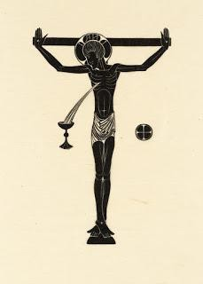

Opening Prayers

In the name of the Father, and of the ☩ Son, and of the Holy Spirit.
Amen

Lord, have mercy.
Christ, have mercy.
Lord, have mercy.

Our Father, who art in heaven,
hallowed be thy name,
thy kingdom come,
thy will be done,
on earth as it is in heaven.
Give us this day our daily bread;
and forgive us our trespasses,
as we forgive those
who trespass against us;
and lead us not into temptation,
but deliver us from evil.
For thine is the kingdom,
and the power, and the glory,
forever and ever. Amen.

We will glory in the cross of our Lord Jesus Christ,
in whom is our salvation, our life, and resurrection.

Let us pray.
Mercifully assist us, O Lord God of our salvation, that we may remember with joy the mighty acts whereby you have given us life everlasting; through Jesus Christ our Lord.
Amen

First Station

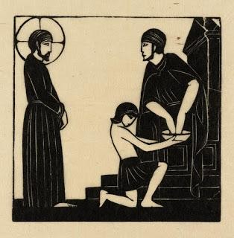

Jesus is Condemned to Death*

We adore you, O Christ, and we bless you.
By your holy cross you have redeemed the world.

As soon as it was morning, the chief priests held a consultation with the elders and scribes and the whole council. They bound Jesus, led him away, and handed him over to Pilate. Pilate spoke to the crowd: “What do you wish me to do with the man you call the king of the Jews?” They shouted back, “Crucify him!” Pilate said to them, “Why, what evil has he done?” But they shouted all the more, “Crucify him!” So, after flogging Jesus, Pilate handed him over to be crucified.

God did not spare his own Son,
but delivered him up for us all.

Let us pray.
Almighty God, your Son our Savior suffered at the hands of sinners and endured the shame of the cross. Grant that we may walk in the way of his cross and find it the way of life and peace; through your Son, Jesus Christ our Lord. Amen

Holy God, holy and mighty, holy and immortal,
have mercy and hear us.
Second Station

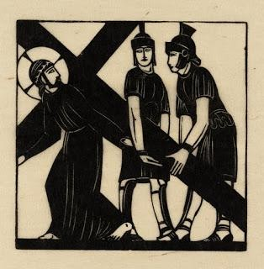

Jesus Receives His Cross

We adore you, O Christ, and we bless you.
By your holy cross you have redeemed the world.

Carrying the cross by himself, Jesus went out to the place called The Place of the Skull, which in Hebrew is called Golgotha. Although he was a Son, he learned obedience through what he suffered. Like a lamb that is led to the slaughter and like a sheep that before its shearers is silent, so he did not open his mouth. Worthy is the Lamb who was slain to receive power and riches, and wisdom and strength, and honor and glory and blessing.

The Lord has laid on him the iniquity of us all:
for the transgression of my people was he stricken.

Let us pray.
Almighty God, whose beloved Son willingly endured the agony and shame of the cross for our redemption: Give us courage to take up our cross and follow him; who lives and reigns forever and ever. Amen

Holy God, holy and mighty, holy and immortal,
have mercy and hear us.
Third Station

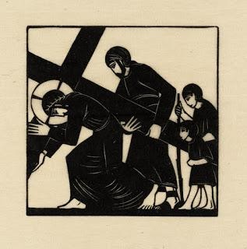

Simon of Cyrene Helps Jesus to Carry the Cross

We adore you, O Christ, and we bless you.
By your holy cross you have redeemed the world.

As they led Jesus away, they seized a man, Simon of Cyrene, who was coming from the country, and they laid the cross on him, and made him carry it behind Jesus. “If any want to become my followers, let them deny themselves and take up their cross and follow me. Take my yoke upon you, and learn from me; for my yoke is easy, and my burden is light.”
Whoever does not carry the cross and follow me cannot be my disciple.

Let us pray.
Heavenly Father, whose blessed Son came not to be served but to serve: Bless all who, following in his steps, give themselves to the service of others; that with wisdom, patience, and courage, they may minister in his name to the suffering, the friendless, and the needy; for the love of him who laid down his life for us, your Son our Savior Jesus Christ. Amen

Holy God, holy and mighty, holy and immortal,
have mercy and hear us.

Fourth Station

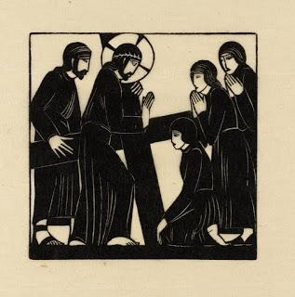

Jesus Speaks to the Women of Jerusalem

We adore you, O Christ, and we bless you.
By your holy cross you have redeemed the world.

A great number of the people followed Jesus, and among them were women who were wailing for him. But Jesus turned to them and said, “Daughters of Jerusalem, do not weep for me, but weep for yourselves and for your children.”

Those who sowed with tears
will reap with songs of joy.

Let us pray.
Teach your church, O Lord, to mourn the sins of which it is guilty, and to repent and forsake them; that, by your pardoning grace, the results of our iniquities may not be visited upon our children and our children’s children; through Jesus Christ our Lord. Amen

Holy God, holy and mighty, holy and immortal,
have mercy and hear us.

Fifth Station

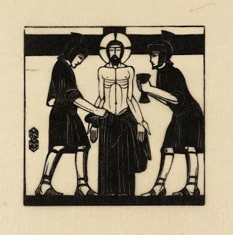

Jesus is Stripped

We adore you, O Christ, and we bless you.
By your holy cross you have redeemed the world.

When they came to a place called Golgotha, they offered him wine to drink, mixed with gall; but when he tasted it, he would not drink it. The soldiers divided his garments among them by casting lots. This was to fulfill what the scripture says, “They divided my clothes among themselves, and for my clothing they cast lots.”

They gave me gall to eat,
and when I was thirsty they gave me vinegar to drink.

Let us pray.
O God, your Son chose the path which led to pain before joy and the cross before glory. Plant his cross in our hearts, so that in its power and love we may come at last to joy and glory; through your Son, Jesus Christ our Lord. Amen

Holy God, holy and mighty, holy and immortal,
have mercy and hear us.

Sixth Station

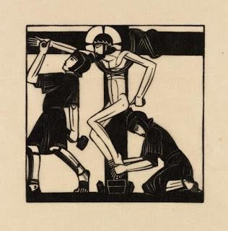

Jesus is Nailed to the Cross

We adore you, O Christ, and we bless you.
By your holy cross you have redeemed the world.

When they came to the place that is called The Skull, there they crucified Jesus; and with him they crucified two criminals, one on the right, and one on the left. He poured out himself to death, and yet he bore the sin of many.

They pierce my hands and my feet;
they stare and gloat over me.

Let us pray.
Lord Jesus Christ, you stretched out your arms of love on the hard wood of the cross that everyone might come within the reach of your saving embrace. So clothe us in your Spirit that we, reaching forth our hands in love, may bring those who do not know you to the knowledge and love of you; for the honor of your name. Amen

Holy God, holy and mighty, holy and immortal,
have mercy and hear us.

Seventh Station

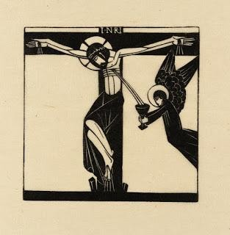

Jesus Dies Upon the Cross

We adore you, O Christ, and we bless you.
By your holy cross you have redeemed the world.

When Jesus saw his mother and the disciple whom he loved standing beside her, he said to his mother, “Woman, behold your son.” Then he said to the disciple, “Behold your mother.” And when Jesus had received the vinegar he said, “It is finished!” Then he bowed his head and gave up his spirit.

Christ for us became obedient unto death,
even death on a cross.

Let us pray.
O God, you gave your only Son to suffer death on the cross for our redemption, and by his glorious resurrection you delivered us from the power of death. Make us die every day to sin, so that we may live with him forever in the joy of the resurrection; who lives and reigns now and forever. Amen

Holy God, holy and mighty, holy and immortal,
have mercy and hear us.

Eighth Station

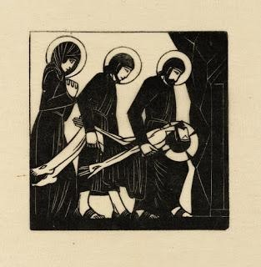

The Body of Jesus is Laid in the tomb

We adore you, O Christ, and we bless you.
By your holy cross you have redeemed the world.

When it was evening, there came a rich man from Arimathea, named Joseph, who was also a disciple of Jesus. He went to Pilate and asked for the body of Jesus. Then Pilate ordered it to be given to him. So Joseph took the body and wrapped it in a clean linen cloth and laid it in his own new tomb, which he had hewn in the rock. He then rolled a great stone to the door of the tomb.

You will not abandon me to the grave,
nor let your holy one see corruption.

Let us pray.
O God, your blessed Son was laid in a tomb in a garden, and rested on the Sabbath day. Grant that we who have been buried with him in the waters of baptism may find our perfect rest in his eternal and glorious kingdom; where he lives and reigns forever and ever. Amen

Holy God, holy and mighty, holy and immortal,
have mercy and hear us.

Conclusion

Savior of the world, by your cross and precious blood you have redeemed us.
Save us and help us, we humbly beseech you, O Lord.

Let us pray.
We thank you, heavenly Father, that you have delivered us from the dominion of sin and death and brought us into the kingdom of your Son; and we pray that, as by his death he has recalled us to life, so by his love he may raise us to eternal joys; who lives and reigns with you, in the unity of the Holy Spirit, one God, now and forever.
Amen

To Christ our Lord who loves us, washed us in his own blood, and made us a kingdom of priests to serve his God and Father, to him be glory and dominion forever and ever.
Amen

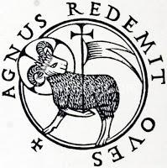

Notes

The Way of the Cross is a devotion adapted from a custom observed by Christian pilgrims who said prayers in Jerusalem at a series of places in that city associated with the passion of Jesus.
Traditionally, there have been as many as fourteen stations. Of these, eight are based directly on events of scripture and are included in this rite. Each station includes sentences and responses, scripture verses, and a prayer.
Traditionally, the procession moves to stations at a series of plain wooden crosses placed along the walls of the church. With each cross there may also be a pictorial representation of the event being remembered.
Visual depictions for the stations may include sculpture, paintings, murals, photographs, or modern images, possibly created by people from the community.
From sundaysandseasons.com. Copyright © 2020 Augsburg Fortress. All rights reserved.
* The artwork for each station is displayed with the title of the artist, Eric Gill. Each image is a reproduction of prints by Eric Gill that are in the collection of the Tate. The images are released under Creative Commons License CC-BY-NC-ND 3.0 (Unported).

